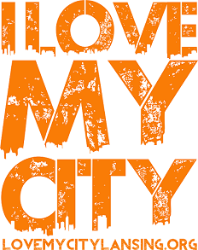

How can you become involved?

There are three ways:

* Become a sponsor.
* Volunteer goods or your time to an existing project.
* Create a project.

To submit a project for your church or organization, go to

lovemycitylansing.org

Scroll to the bottom of the home page and follow these directions:

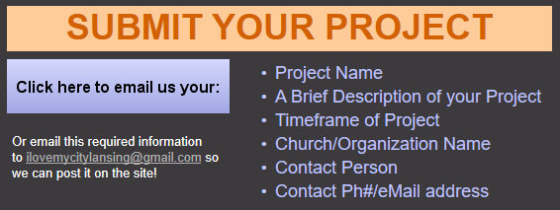

April 26th – May 3rd

I Love My City Lansing is an annual event that gives churches, government, and local businesses a unique opportunity to join together at various projects around the city, to show the community that they are **LOVED**!





How can you become involved?

There are three ways:

* Become a sponsor.
* Volunteer goods or your time to an existing project.
* Create a project.

To submit a project for your church or organization, go to

lovemycitylansing.org

Scroll to the bottom of the home page and follow these directions:



April 26th – May 3rd

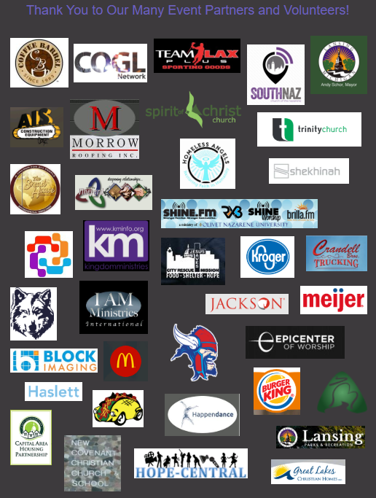

Partner with us, in any way, and we will add your company logo to our partners page. **Each logo** in on the page links to the matching partner **website**!



Partner with us, in any way, and we will add your company logo to our partners page. **Each logo** in on the page links to the matching partner website!