I Love My City Lansing is an annual event that gives churches, government, and local businesses a unique opportunity to join together at various projects around the city, to show the community that they are **LOVED**!

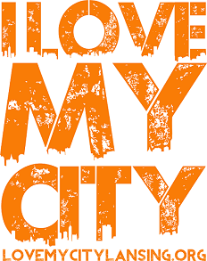

**April 26 – May 3, 2020**

Wouldn’t it be great if the company you work for got involved?

*What are you waiting for?*

ASK YOUR BOSS!

Would someone you do business with want to participate??

FIND OUT!

Do you know a person or people at work who love to volunteer?

ASK THEM!

Encourage them to visit our website:

lovemycitylansing.org

Once there they can contact us with their desire to be a sponsor, their project ideas or to just sign up to volunteer and donate goods to the existing projects!

Thank-you!

I Love My City Lansing is an annual event that gives churches, government, and local businesses a unique opportunity to join together at various projects around the city, to show the community that they are **LOVED**!



**April 26 – May 3, 2020**

Wouldn’t it be great if the company you work for got involved?

*What are you waiting for?*

ASK YOUR BOSS!

Would someone you do business with want to participate??

FIND OUT!

Do you know a person or people at work who love to volunteer?

ASK THEM!

Encourage them to visit our website:

lovemycitylansing.org

Once there they can contact us with their desire to be a sponsor, their project ideas or to just sign up to volunteer and donate goods to the existing projects!

Thank-you!

I Love My City Lansing is an annual event that gives churches, government, and local businesses a unique opportunity to join together at various projects around the city, to show the community that they are **LOVED**!



**April 26 – May 3, 2020**

Wouldn’t it be great if the company you work for got involved?

*What are you waiting for?*

ASK YOUR BOSS!

Would someone you do business with want to participate??

FIND OUT!

Do you know a person or people at work who love to volunteer?

ASK THEM!

Encourage them to visit our website:

lovemycitylansing.org

Once there they can contact us with their desire to be a sponsor, their project ideas or to just sign up to volunteer and donate goods to the existing projects!

Thank-you!

